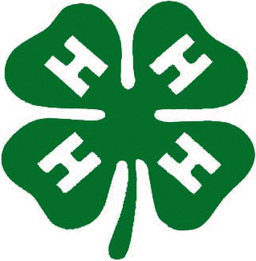
2017 State 4-H Rodeo Finals
August 18 - 20, 2017
Sponsorship Form

Business: ________________ Contact Person: __________________
Address: _________________ City, State, Zip: ___________________
Phone:___________________ Email Address: ___________________

Program Advertising: (Circle one location and one price.)

Ad Location | Full Page | 1/2 Page | 1/4 Page | 1/8 Page
Back Cover | $325 | $225
Inside Front Cover | $325 | $225
Inside Back Cover | $275 | $175
Inside Pages | $175 | $100 | $60 | $45
Total: ____________ Paid by Check No. ___________

Sponsorships:

Saddle Sponsor: |  | $350 |  | $700
 |  | Half Saddle |  | Full Saddle
Chute Gate Sponsor: |  | $350
Event Sponsor: |  | $250
Buckle Sponsor: |  | $100
Total: ___________ Paid by Check No. __________

Please submit camera ready artwork to sd4hrodeoad@gmail.com or to the mailing address below no later than July 7, 2017.

Questions Contact: Vickie (605)222-9517 or Teri (605)280-9420 or sd4hrodeoad@gmail.com

Thank You for helping make the 2017 State 4-H Rodeo Finals a Success!
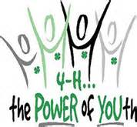
Please return this form by June 16, 2017 with payment to:

South Dakota 4-H Rodeo Finals, Inc.
Attn: Program
P.O. Box 1232
Pierre, SD 57501

